ARTIFICIAL INTELLIGENCE – PROJECT 2

DATA CLASSIFICATION USING AI

1. Introduction
Artificial Intelligence enables computers to learn patterns from data and make predictions. In this project, a basic supervised learning classification model is developed using the Iris Flower Dataset.
The objective of this project is to understand the basic classification workflow, including loading a dataset, preparing the data, splitting it into training and testing sets, training a classification model, making predictions, and evaluating the model.

2. Project Objective
The main objective of this project is to build a basic classification model using a small dataset.
The project focuses on:
- Loading and understanding a dataset
- Preparing the data for machine learning
- Splitting the data into training and testing sets
- Applying a simple classification algorithm
- Training the AI model
- Making predictions
- Evaluating the model performance
These activities follow the main requirements given for Project 2 in the provided training document.

3. Dataset Used
For this project, the Iris Flower Dataset was used.
The dataset contains measurements of iris flowers and is used to classify flowers into three different species:
- Setosa
- Versicolor
- Virginica
The dataset contains 150 records and 4 input features.

4. Features Used
The four input features are:
- Sepal Length
- Sepal Width
- Petal Length
- Petal Width
These measurements are provided to the machine learning model as input data.

5. Tools and Technologies
The following tools and technologies were used:
- Python
- Jupyter Notebook
- Pandas
- NumPy
- Matplotlib
- Seaborn
- Scikit-learn

6. Data Preparation
The Iris dataset was loaded using Scikit-learn.
The dataset was converted into a Pandas DataFrame for easier analysis.
The input variables were stored in X, while the target variable was stored in y.
The dataset was also checked for missing values.

7. Train-Test Split
The dataset was divided into two parts:
- 80% training data – 120 records
- 20% testing data – 30 records
The training data was used to train the classification model, while the testing data was used to evaluate its predictions.

8. Classification Algorithm
The K-Nearest Neighbors (KNN) algorithm was used for classification.
The model was created with:
n_neighbors = 3
KNN classifies a new data point by considering the nearest data points in the training dataset.

9. Model Training
The KNN model was trained using the training data.
The model learned patterns from the flower measurements and their corresponding target classes.

10. Prediction
After training, the model was used to predict the classes of the testing data.
The predicted values were compared with the actual target values to evaluate the model.

11. Model Evaluation
The model was evaluated using:
- Accuracy Score
- Classification Report
- Confusion Matrix
The accuracy obtained from the Jupyter Notebook should be entered below:
Model Accuracy: __________ %
The classification report provides precision, recall, F1-score, and support for each flower class.

12. Confusion Matrix
A confusion matrix was created to compare the actual classes with the predicted classes.
The confusion matrix helps identify the number of correctly and incorrectly classified samples for each Iris flower species.
Insert your Confusion Matrix screenshot here.

13. Results
The trained KNN model successfully classified the Iris flower samples based on their measurements.
The model's performance was evaluated using the testing dataset. The final accuracy should be reported using the actual value obtained from the Jupyter Notebook.
Final Accuracy: __________ %

14. Conclusion
This project provided practical experience with the basic supervised learning classification process.
The project demonstrated how to:
- Load and understand a dataset
- Prepare input and target data
- Split data into training and testing sets
- Apply a classification algorithm
- Train an AI model
- Make predictions
- Evaluate model performance
Overall, the project helped in understanding the fundamental workflow of Data Classification Using AI and basic supervised learning.

15. Future Learning
As suggested in the training material, further learning can include experimenting with different algorithms and testing the model with new data.

PROJECT DETAILS
Project: Artificial Intelligence – Project 2
Topic: Data Classification Using AI
Dataset: Iris Flower Dataset
Algorithm: K-Nearest Neighbors (KNN)
Training Data: 120 records
Testing Data: 30 records
Accuracy: __________ %
Submitted By:
Vaheeda Begum
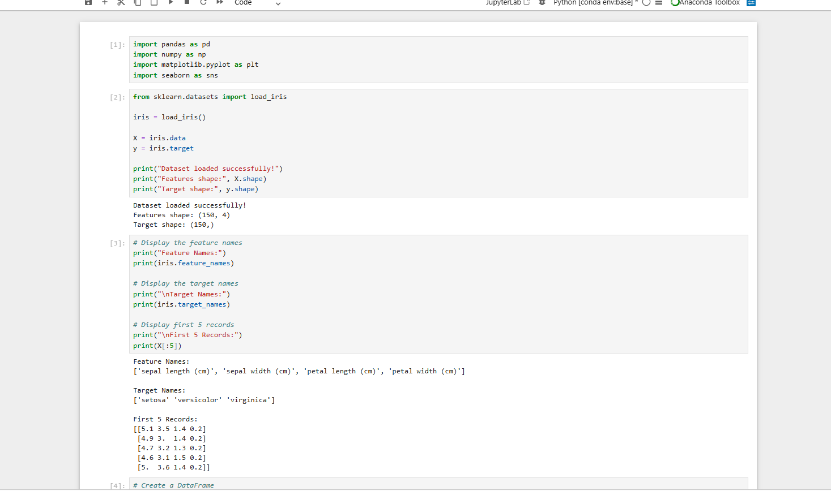
Figure 1: Iris Dataset Preview

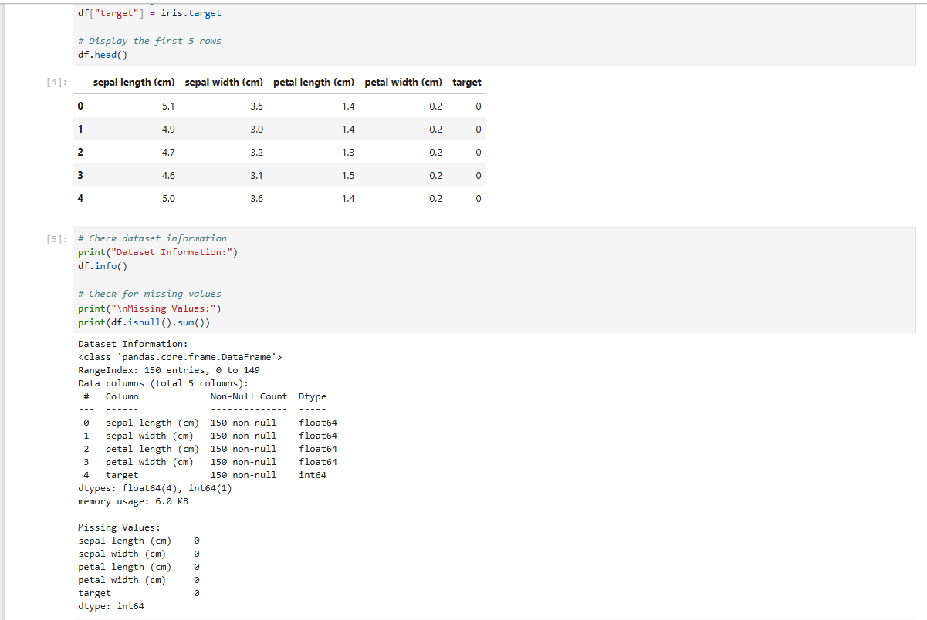
Figure 2: Training and Testing Data Split

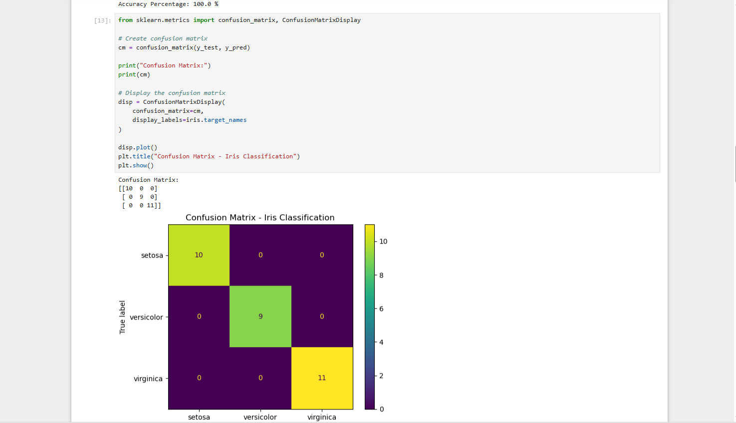
Figure 3: KNN Model Accuracy

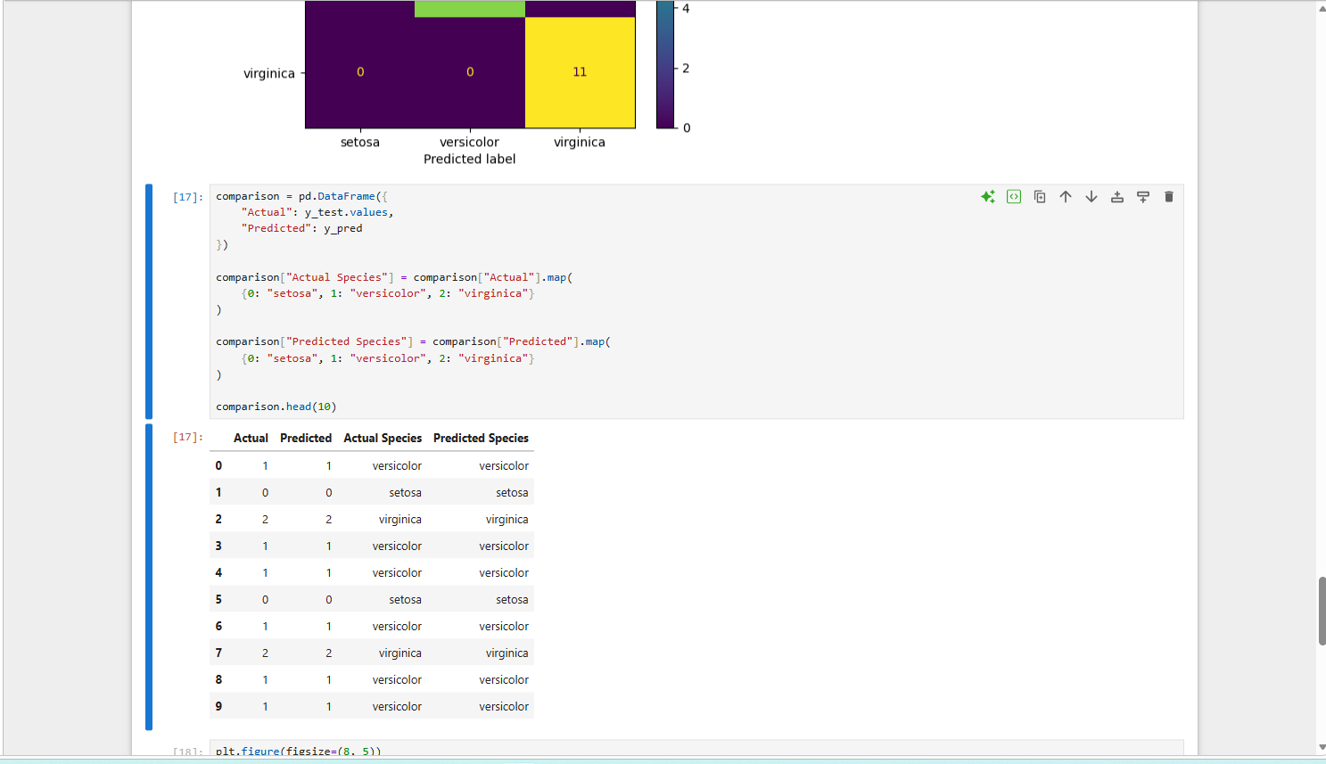
Figure 4: Classification Report

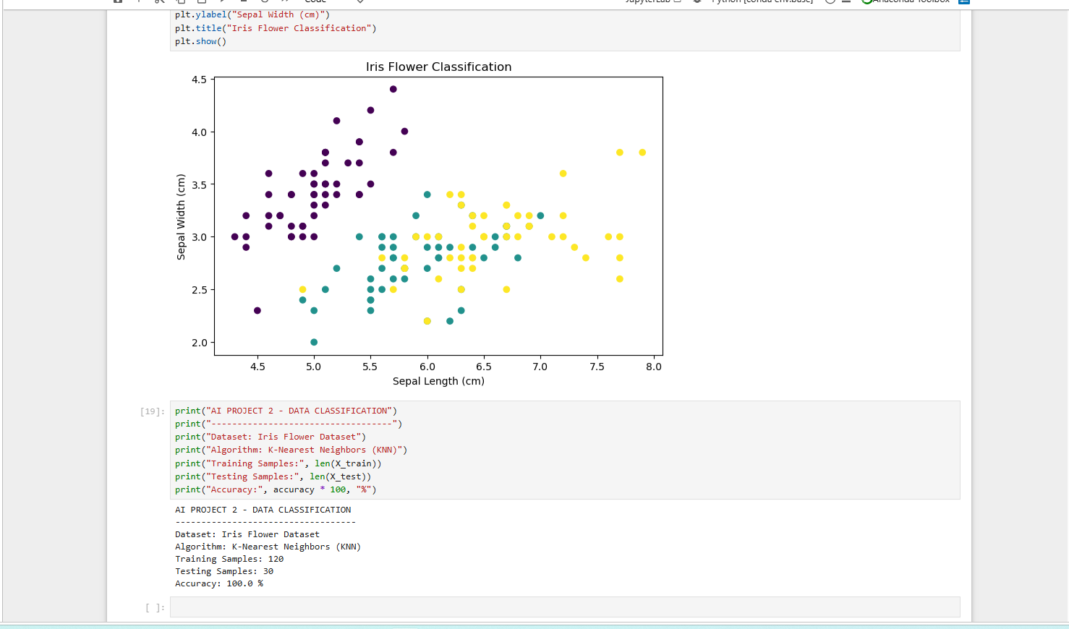
Figure 5: Confusion Matrix

